**Instructions**

First you will familiarise yourself with the tasks before doing them in the MRI scanner. Please read the following instructions carefully.

On the screen you will see a picture and an incomplete word. One of these will have a coloured frame around it, and you will be focusing on the one with the coloured frame. The frame’s colour will indicate which task to do.

When you see a **black** frame, you do not need to do anything – just rest for a moment and wait for the next one.

The red and green frames tell you to make one of two judgements about the picture.

If the frame is **red,** you will judge whether the framed picture is **living.** For example, you will answer **yes** for a cat, and **no** for a chair.

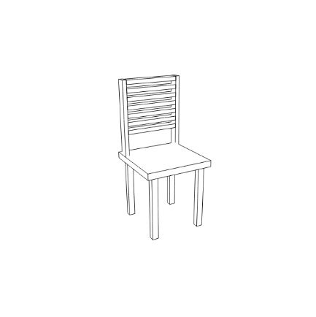

Is it living?

If the frame is **green,** you will judge whether the framed item fits into a shoebox. You would answer **yes** for paperclip, **no** for an elephant.



Does it fit into a shoebox?

The blue and yellow frames tell you to make a judgement about the word.

If the frame is **blue**, decide whether the letter **‘A’** can fit in the blank space to make a word. For example, if you saw ‘BE_N’, you would answer **yes.**

Does ‘A’ fit in to make a word?

**BE_N**

If the frame is **yellow,** decide whether the letter **‘I’** can fit in the blank space to make a word. For example, for the same incomplete word ‘BE_N’, you would answer **no.**

Does ‘I’ fit in to make a word?

**RA_N**

In the MRI scanner, you will use a button box with four keys. Put your left hand index finger on the leftmost button. Put your right hand index finger and middle finger on top of the two keys at the right. Use your index finger for ‘Yes’ and middle finger for ‘No’.

Space button

Yes

No